Medicaid Funding Basics + Block Grant & Caps Explainer
In this toolkit, you will learn how Medicaid is funded. You will also learn how block grants and per capita caps impact people with disabilities.
For questions, contact Kim Musheno at musheno@thearc.org.

What Is Medicaid?
Medicaid is the largest public health insurance program for people with disabilities. It offers free or low-cost health insurance for eligible low-income adults, children, older adults, and people with disabilities. Over 85 million Americans are covered. Medicaid is also the single largest source of federal funding for states.
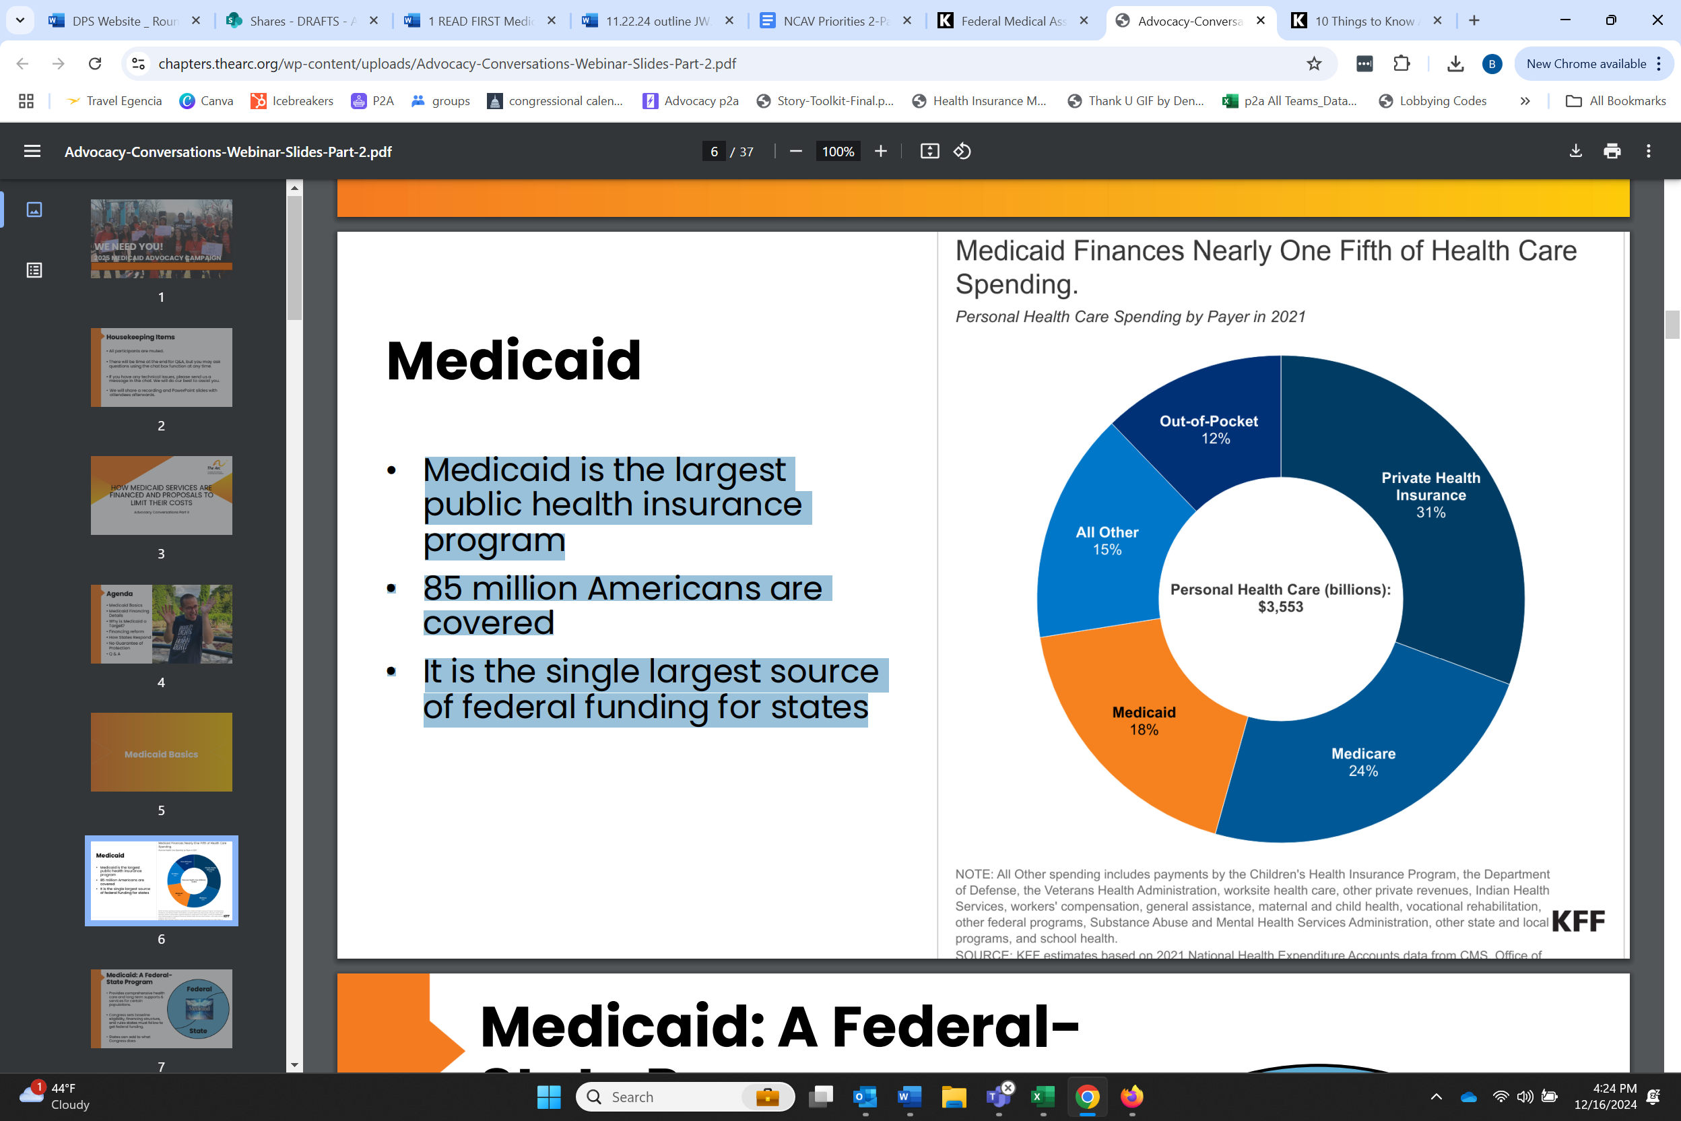

How Does Medicaid Work Federally and at the State Level?
- Provides comprehensive health care and long-term supports and services for certain populations.
- Congress sets baseline eligibility, financing structure, and rules states must follow to get federal funding.
- States can add to what Congress does.
  - States decide which optional services to provide and what optional categories of people are served.
  - States make many of the decisions related to implementation of the program such as setting Medicaid reimbursement rates for providers.

State vs. Federal Payments
The federal medical assistance percentage (FMAP) is the percentage of Medicaid expenditures paid for by the federal government. These rates are determined annually for every state and based on the state’s per capita income relative to the national average. Find your state’s FMAP here.
State Payment
Federal Payment

FMAP Examples
Small percentages can have a huge impact. For every dollar a state puts in, the federal government will put in $1, $2, or $3. States can generate their match through general revenue, provider taxes, and county payments.
See below for an example.

What Are Block Grants and Per-Capita Caps?
Block grants are a fundamental change to how Medicaid is funded. This provides states with a fixed amount of money. This fundamentally changes how Medicaid works by removing the automatic federal payment for approved state spending. The fixed amount provided to the state is usually lower than the expected growth in Medicaid. The fixed amounts might not take into account the aging population, rising costs of health care, enrollment increases during public health emergencies, and other reasons Medicaid enrollment may rise.
The difference between the fixed amount the state receives and the costs means that states must decide if they can make up the difference or make difficult decisions about what to cut. This can lead to cuts in coverage, services, provider reimbursements, or other state spending to make up the difference. States may have to choose whether to cut nursing home care, disability services, or reduce the number of children receiving health care. Per-capita caps are another way to restructure Medicaid that would set a fixed amount of federal Medicaid funding for each enrollee.


How Can States Make Up for the Federal Funding Lost?
- Raise taxes
- Shift funding from other state budgets
- Make changes within the Medicaid program
This can lead to tough challenges for states. There can be longer waitlists or the elimination of optional services, like home and community-based services.

